NEPAL TOUR - 8 Days
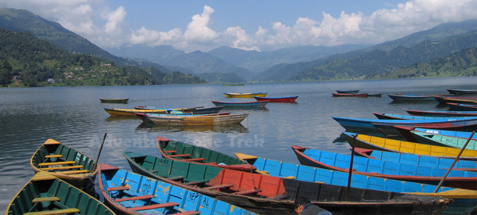 | 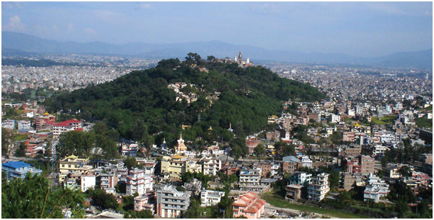
Itinerary:
Day 01: Arrival at Kathmandu airport
You will be met by our representative and transfer to hotel. After refreshment in hotel, short briefing about the programs
KATHMANDU DURBAR SQUARE: Durbar Square, one of the old capitals of the Kathmandu valley, is a synthesis of Hindu and Buddhist temples, stupas and statues, and is often the site of festivals, marriages and other ceremonies.

Day 02: Kathmandu city sightseeing (1315m)
Today we explore the Kathmandu valley.
SWOYAMBBHUNATH: Climb the many steps to Swayambhunath (the monkey temple) with its commanding views of Kathmandu, its whitewashed stupas and its unique synthesis of Buddhism and Hinduism.
PASHUPATINATH: It’s a sacred temple complex on the banks of the holy Bagmati river. Here, monkeys run up and down the steps of the burning ghats, and trident-bearing saddhus draped in burnt-orange and yellow sit serenely meditating - when they are not posing for photos for rupees.
BOUDHANATH: The striking Buddha eyes of Boudhanath Stupa watch over a lively and colorful Tibetan community and attract pilgrims from all over the Himalayan Buddhist realm. In the midst of traditional gompas, and hung with long strings of multi-colored prayer flags, Boudhanath attracts Sherpas, Tibetans and tourists alike for daily circumambulations (koras) of the stupa.
Day 03: Kathmandu - Pokhara:
Early morning after breakfast drive to Pokhara by private Car. Upon arrival, check into the hotel. Your afternoon is free for personal activities and a 1-hour boat ride on Fewa lake. Dinner and overnight stay at hotel.
Day 04: Pokhara Tour
Pokhara is a natural capital of Nepal and a starting point of trekking in Annapurna. Pokhara exploration includes drive or hike to several view points for different perspectives of geographical enigmas. One can hike and mountain bike to several hillsides like Sarangkot, World Peace Stupa etc. The Tibetan Refugee Camp is another palce of interest in Pokhara. Your exploration sites will be designed according to your preferences.
Pokhara sightseeing Points: International Mountain Museum, Sarangkot Sunrise View, Devi's Fall, Tibetan Refugee Camp, World Peace Stupa.
Day 05: Pokhara – Kathmandu:
Early morning after breakfast we'll visit Nepal Mountaineering Museum & later we will drop you at Domestic airport for flight back to Kathmandu. Transfer to Hotel. Evening at leisure.
Day 06: Kathmandu – Nagarkot:
Drive to Nagarkot. Nagarkot is situated 32 kilometers, 1.5 hrs drive east of Kathmandu at an altitude of 2,175 meters. The panoramic view of the major peaks can be seen from here. This place is also famous for viewing sunrise and sunset. Overnight at hotel
Day 07: Nagarkot – Kathmandu:
Early morning wake up call to see the magnificent sunrise over the Himalayas. Breakfast and transfer back to Kathamndu on the way we can visit Bhaktapur by private car. Transfer to Hotel.
Day 08: Departure:
Transfer to airport for final departure or continue your onwards trips. Tour ends with THANK YOU!

Package Cost: US $ 1470 each/-

In the aforementioned tours,
It is also possible to take 1 hr mountain flight to Everest.

Service Includes
• All airport transfers
• Accommodation in twin sharing basis with all meals.
• All transfers by private deluxe Japanese vehicle for the sightseeing.
• English speaking tour guide.
• Return flight Pokhara to Kathmandu
• Domestic Airport taxes.
• All Government taxes

Service Excludes
• Lunch & Dinner while stay in Kathmandu, Nagarkot & Pokhara.
• Sightseeing entrance fees
• All bar bills
• Travel insurance
• Any extra cost not mentioned in service includes

